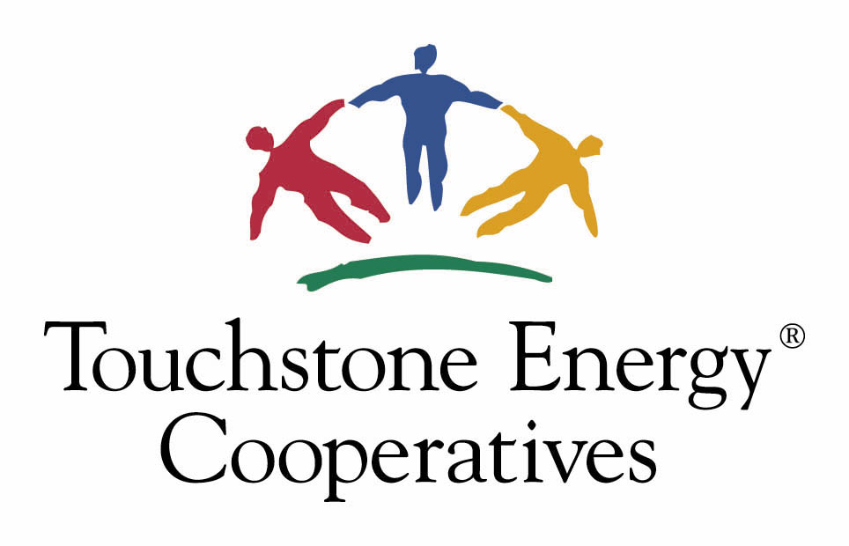

Touchstone Energy®
2024/2025 Classroom Empowerment
Grant Application

Applicant’s Name ____________________________ Title ______________________________

School Name __________________________________________________________________

School Address _________________________________________________________________

Daytime Phone Number ( ) __________________ E-mail _____________________________

Local Touchstone Energy Cooperative _______________________________________________

Project Submitted _______________________________________________________________

Eligibility is limited to schools located in Touchstone Energy cooperative service areas. Teachers and administrators of K-12 public and private schools may apply. For more information about Touchstone Energy, see the enclosed fact sheet or log on to www.touchstoneenergy.coop. Touchstone Energy reserves the right to photograph the grant winners and use the photos for publicity purposes. Projects must be completed by the time school is out for the summer. Incomplete entries will be deemed ineligible and will not be judged.

Deadline: Application forms must be received by your local electric cooperative by mail, e-mail or fax no later than November 8, 2024. Awards will be announced on January 29, 2025.

For additional questions, please call SouthEastern Illinois Electric Cooperative (618) 273-3806 or e-mail Stefanie Tripp at stefanietripp@seiec.com. Mail grant applications to: SEIEC, Attn: Stefanie Tripp,
P. O. Box 1001, Carrier Mills, IL 62917.

Judging Process:
Applications will be reviewed by an impartial panel of judges. If necessary, applicants may be contacted for additional information.

Signed: ____________________________________ Date: ______________________________
(Teacher or Administrator)
If I receive the grant, I pledge to follow all completion requirements and provide written proof of completion within six months of my project’s end.

